SRVUSD Homework Policy
In an effort to reduce student stress and respond to the evolving instructional practices, SRVUSD convened a committee of teachers, students, parents and school administrators to recommend updates to SRVUSD homework policy and regulation. The committee considered and made changes related to:
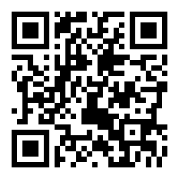
- Limiting the overall volume of homework;
- Eliminating homework over breaks;
- Developing a more effective system for communicating and implementing the policy; and
- Aligning with the Common Core State Standards and other legal requirements.

On June 23, 2015, the SRVUSD Board of Education adopted a new Homework/Make-Up Work Board Policy and Administrative Regulation. To view the Board Policy and Administrative Regulation in their entirety, scan the adjacent QR code or click on the link: www.srvusd.net/homeworkpolicy

